**ESTIMATION OF BUSINESS EXPENCES**

**TEAM NO : 2**

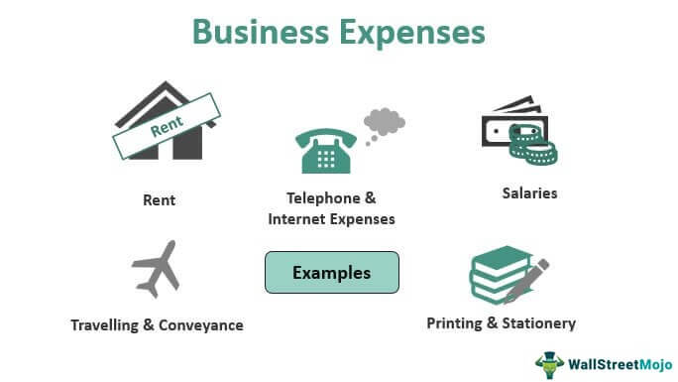

**M MUTHUKUMARAN**

TEAM NO : 2

GOVERNMENT ARTS COLLEGE FOR MEN, NANDANAM

**1 INTRODUCTION**

1.1 OVER VIEW

My team’s this project explains that estimation of business expensive in India.

1.2 PURPOSE

This project explains the business expensive in Indian country.

And it gives more information about it.

**2 PROBLEM DEFINITION & DESIGN THINKING**

2.2 EMPATHY MAP

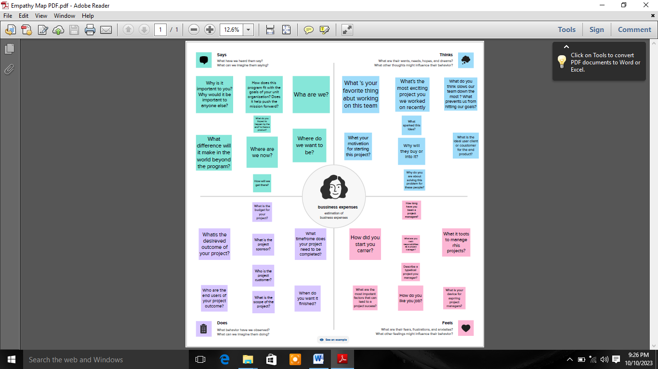

2.2 IDEATIONN & BRAINSTORMING MAP

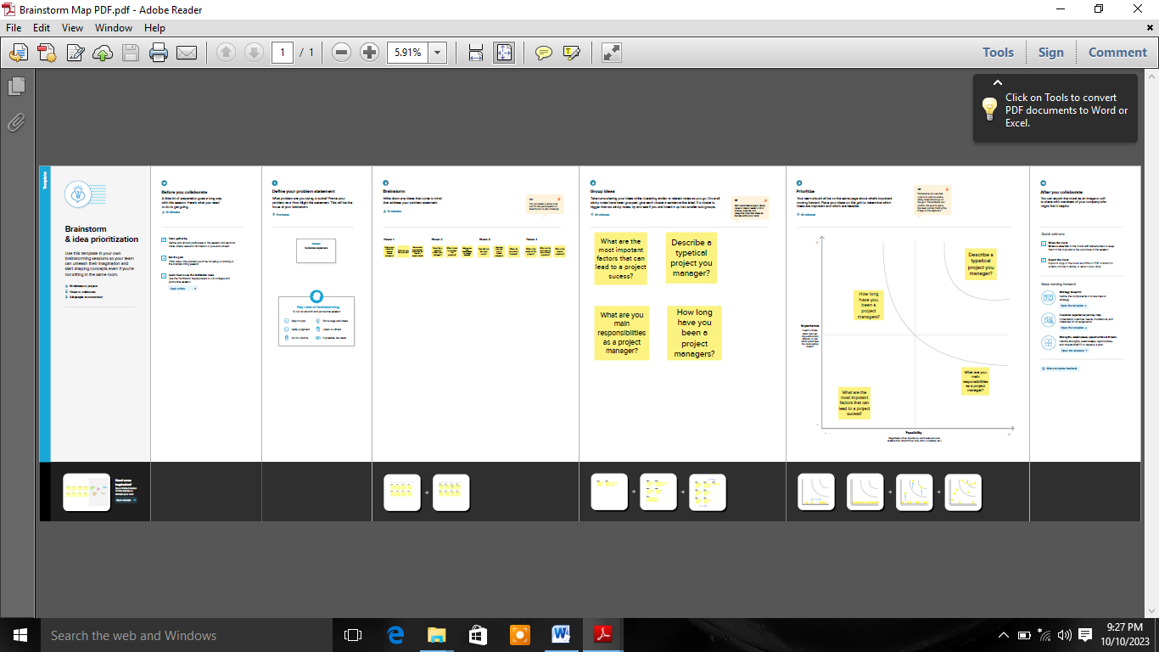

**3 RESULT**

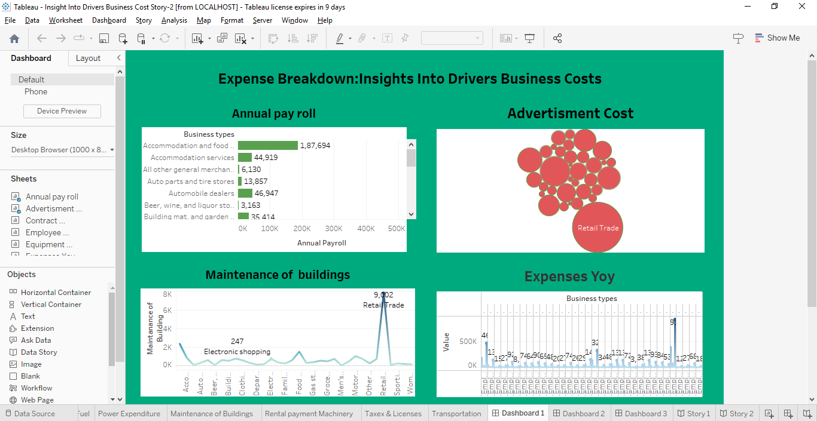

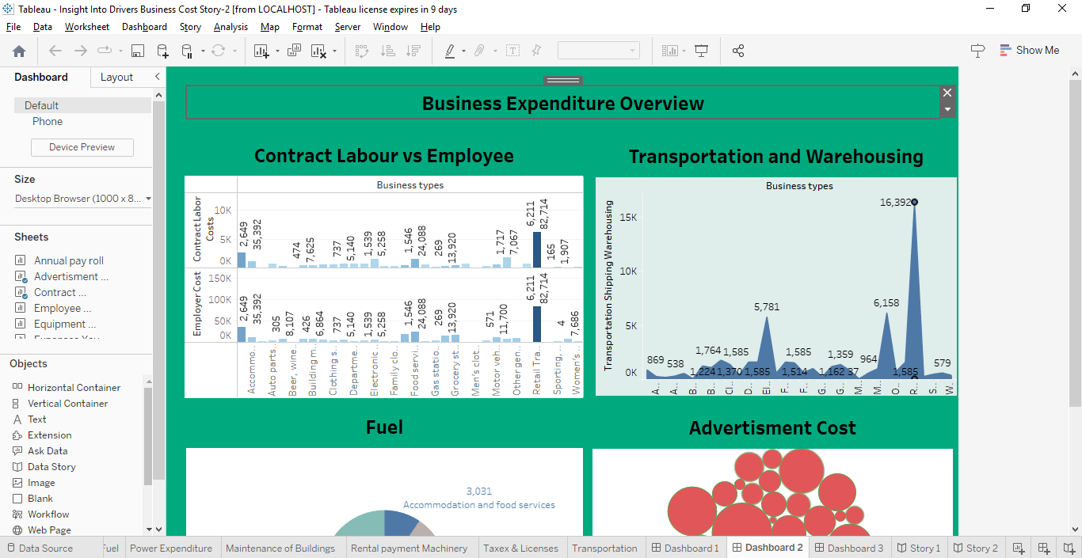

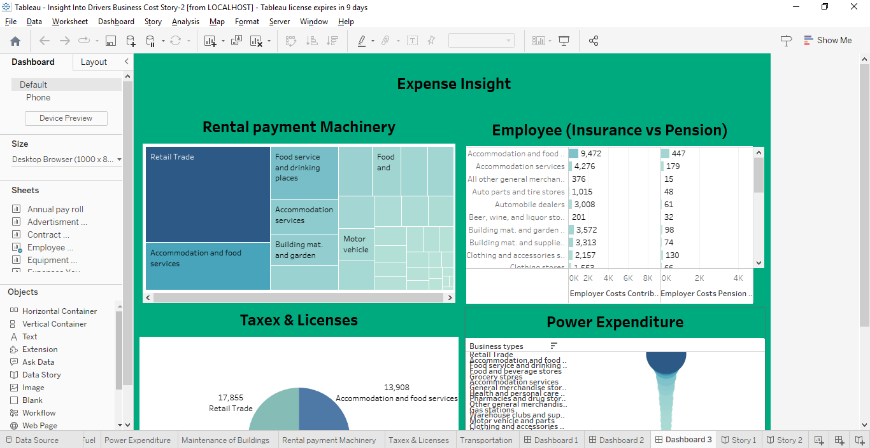

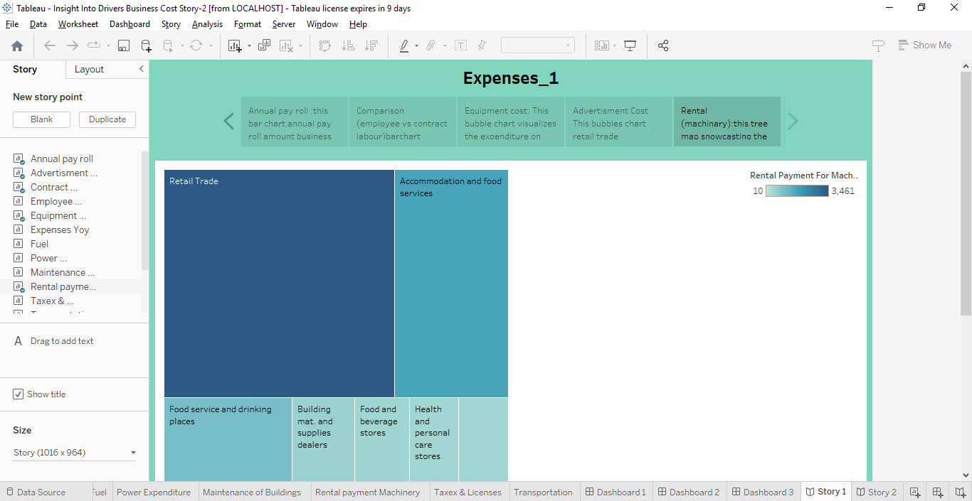

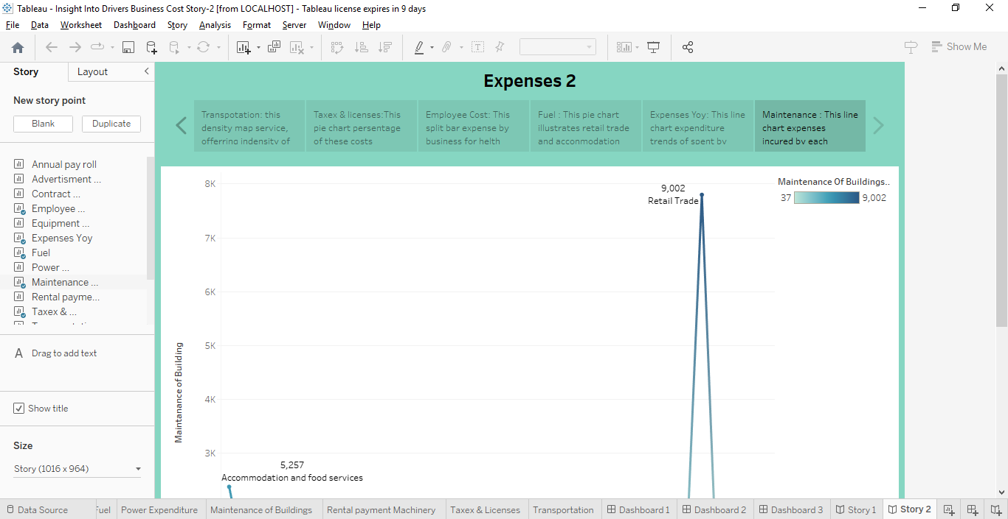

**4 (1) ADVANTAGES**

* The amount can be deducted from your income and lower your tax liability.
* Large expenses that increase the long-term value of your business like buying new equipment or investing in a new building are considered capital expenditures and are handled differently than other expenses.

**4 (1) DISADVANTAGES**

* Costing methods are typically not useful for figuring out tax liabilities, which means that cost accounting can't provide a complete analysis of a company's true costs.
* It is less reliable for old properties as it is difficult to estimate the depreciation of properties that are older.

**5 APPLICATIONS**

* To sum up, keeping track of business expenses is an essential aspect of running a successful company.
* It helps you to make informed financial decisions and stay on top of your cash flow.
* Neglecting this important task can lead to serious consequences, such as legal penalties and potential bankruptcy.

**6 CONCLUSION**

This project explains estimation of business expensive and my project gives Information about it…

**7 FUTURE SCOPE**

* Cost estimation in project management is the process of forecasting the financial and other resources needed to complete a project within a defined scope.
* Cost estimation accounts for each element required for the project — from materials to labor — and calculates a total amount that determines a project's budget.
* There are different methods to estimate the project scope, depending on the level of detail, accuracy, and certainty you have. Some of the common methods are analogous estimation, parametric estimation, bottom-up estimation, and three-point estimation.